Unit 2: Linear Functions

Unit Overview:
In this unit you will be using the information you learned about linear functions in Algebra 1 and applying it to real world problems. You will be using li near inequalities and linear programming to solve 2 variable equations. You will also learn to solve 3 variable equations using three different methods.

Essential Questions:

- What are ways linear regression can be applied to business settings?
- How can systems of linear inequalities be used in business models?
- How can using 3 variable systems be used to solve real world problems?
- When can absolute value equations be used in applications?

Objectives:

You will:

Lesson 1:
- Use linear regression to determine the line of best fit for a given data set.
- Use information from linear regression and systems of equations to make decisions as a consumer and business owner.
- Compare two data sets by using linear regression and systems of equations.
Lesson 2:
- Write a system of linear inequalities with a solution set that forms a given triangle on a plane.
- Write and solve a system of two linear inequalities.
- Determine possible solutions to a system of linear inequalities.
- Write an objective function for a linear programming problem.
- Maximize or minimize a real world problem given 3 or more constraints.
Lesson 3:
- Write a system of equations with 3 variables.
- Solve a system of 3 equations with 3 variables using Gaussian elimination.
- Solve a system of 3 equations with 3 variables using technology with matrices.
- Solve a system of 3 equations with 3 variables using substitution.
- Solve a system of equations where one equation is linear and the other quadratic.
Lesson 4:
- Graph .
- Identify the key attributes of such as domain, range, intercepts, symmetry and maximum/minimum of the absolute value function.
- Analyze the effects of a, b, c, and d on the graph of.
- Write an absolute value equation given two linear equations.
- Solve an absolute value equation.
- Solve an absolute value inequality.

TEKS:

(1A) apply mathematics to problems arising in everyday life, society, and the workplace;
(1B) use a problem-solving model that incorporates analyzing given information, formulating a plan or strategy, determining a solution, justifying the solution, and evaluating the problem-solving process and the reasonableness of the solution;
(1C) select tools, including real objects, manipulatives, paper and pencil, and technology as appropriate, and techniques, including mental math, estimation, and number sense as appropriate, tosolve problems;
(1D) communicate mathematical ideas, reasoning, and their implications using multiple representations, including symbols, diagrams, graphs, and language as appropriate;
(1E) create and use representations to organize, record, and communicate mathematical ideas;
(1F) analyze mathematical relationships to connect and communicate mathematical ideas; and
(1G) display, explain, or justify mathematical ideas and arguments using precise mathematical language in written or oral communication.
(2A) graph the functions f(x)=√x, f(x)=1/x, f(x)=x³, f(x)= ³√x, f(x)=b^{x}, f(x)=|x|, and f(x)=log_{b} (x) where b is 2, 10, and e, and, when applicable, analyze the key attributes such as domain, range, intercepts, symmetries, asymptotic behavior, and maximum and minimum given an interval;
(3A) formulate systems of equations, including systems consisting of three linear equations in three variables and systems consisting of two equations, the first linear and the second quadratic;
(3B) solve systems of three linear equations in three variables by using Gaussian elimination, technology with matrices, and substitution;
(3E) formulate systems of at least two linear inequalities in two variables;
(3F) solve systems of two or more linear inequalities in two variables; and
(3G) determine possible solutions in the solution set of systems of two or more linear inequalities in two variables.
(6C) analyze the effect on the graphs of f(x) = |x| when f(x) is replaced by af(x), f(bx), f(x-c), and f(x) + d for specific positive and negative real values of a, b, c, and d;
(6D) formulate absolute value linear equations;
(6E) solve absolute value linear equations;
(6F) solve absolute value linear inequalities;
(7I) write the domain and range of a function in interval notation, inequalities, and set notation.
(8B) use regression methods available through technology to write a linear function, a quadratic function, and an exponential function from a given set of data; and
(8C) predict and make decisions and critical judgments from a given set of data using linear, quadratic, and exponential models.

Lesson 2: Systems of Linear Inequalities

Lesson Objectives
You will:
- Write a system of linear inequalities with a solution set that forms a given triangle on a plane.
- Write and solve a system of two linear inequalities.
- Determine possible solutions to a system of linear inequalities.
- Write an objective function for a linear programming problem.
- Maximize or minimize a real world problem given 3 or more constraints.

Engage: Systems of Linear Inequalities
Watch the video Systems of Inequalities. This video will give you a little insight into what we will be looking at in this unit.

Explore: Systems of Linear Inequalities
Print out this worksheet: U02L02Ep. Watch the video Graphing Systems of Linear Inequalities while working through the worksheet.

Explain: Systems of Linear Inequalities
In order to find out which combination of water bottles and soda will make Zeke the most profit, we will need to write an objective function. This function needs the profit that comes from each drink.
Print out this worksheet: U02L02Ex. Watch the video, Linear Programming and work through the worksheet along with the video.
When you have finished the Linear Programming video and the accompanying worksheet, print out this worksheet U02L01Ex1. Now that you know how to solve linear programming problems, work through this worksheet to check for understanding.

Elaborate: Systems of Linear Inequalities
There is another type of system that we should look at quickly. It involves one linear equation and a quadratic equation. Below is an example of how this can be seen in real life.
A rocket is launched from the ground and follows a parabolic path represented by the equation y = – x+ 10. At the same time, a flare is launched from a height of 10 feet and follows a straight path (even though technically due to gravity it would be more of a parabolic shape as well, for the sake of the problem we will assume it was fired straight down and didn’t have time to follow it’s arc) represented by the equation y = – x + 10. Using the accompanying graph, find the coordinates of the point or points where the paths intersect (assuming the flare did not set off the rocket the first time they collide!).
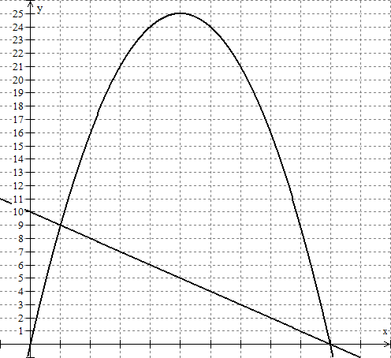

Based on what we know about systems of linear equations, we can apply the same rule to the linear and quadratic system. We know that the solution(s) to the system are where the two lines cross each other. Therefore, in the problem above the solutions are (1, 9) and (10, 0). In terms of the problem, this means that the flare and rocket pass each other after 1 second at 9 feet and meet again at 10 seconds at zero feet (the ground).

Evaluate: Systems of Linear Inequalities Practice Quiz
Use the following information to answer questions 1-5.
I am selling cakes to benefit my favorite charity and of course want to maximize my profit. I can bake between 2 and 6 chocolate cakes each day and between 2 and 7 vanilla cakes each day. However, I can’t make more than 10 total cakes in one day. I can sell each chocolate cake for $12 and each vanilla cake for $10. Using chocolate cake as your x value and vanilla cake as your y value, determine what combination of chocolate and vanilla cakes will maximize my profit.
- Which objective function satisfies the cake problem?
- P = 10x + 12y
- P = 12x + 10
- P = 10x + 12
- P = 12x + 10y *
- What system of linear inequalities will satisfy the above information?
- *
- Using the following graph, identify the vertices.

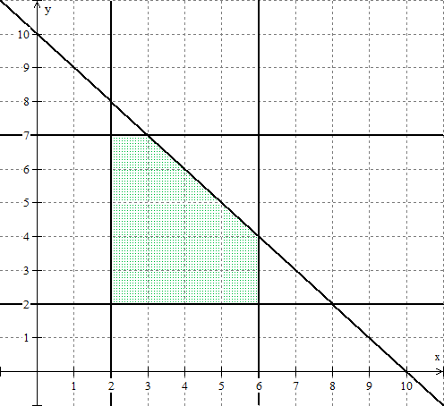
(___, ___) *(2, 2)
(___, ___) *(2, 7)
(___, ___) *(3, 7)
(___, ___) *(6, 4)
(___, ___) *(6, 2)
- Using the vertices to maximize the objective function, which of the following is the correct maximum profit?
- $115
- $110
- $112 *
- $106
- Which of the following is the correct combination of cakes?
- 3 chocolate cakes and 7 vanilla cakes
- 4 chocolate cakes and 6 vanilla cakes
- 6 chocolate cakes and 4 vanilla cakes
- 7 chocolate cakes and 3 vanilla cakes

Evaluate: Systems of Linear Inequalities Graded Assignment
Let’s put your knowledge of linear programming to the test. Recall in the video that Mr. Green needed help figuring out how many plants to buy in order to maximize profit during the Bastille Day Sale.
Here is the information that Mr. Green provided us:
Type of Plant | Square Footage | Gallons of Soil | Cost
Giant Potted | 7 | 14 | $14
Hanging Basket | 4 | 2 | $5
Mr. Green has 168 square feet of space available, 210 gallons of soil and a budget of $252. Each giant potted plant sells for $28 and each hanging plant sells for $8. Write a system of inequalities and determine which combination of plants will maximize profit for Mr. Green.
- Define variables (10 points: 5 for each)
- Write the objective function (10 points)
- Write a system of linear inequalities that represents the problem’s restrictions (20 points: 5 points for each inequality)
- Graph the system of inequalities (25 points: 5 points for each inequality)
- Find the vertices of the region that contains the solutions to the system of linear inequalities (10 points: 2 points for each vertex)
- Test the coordinates of each vertex in the objective function to find the one that gives the maximum profit (15 points: 3 points for testing each vertex)
- State the solution in terms of the variables (10 points)

